NEXTAG COMPANY

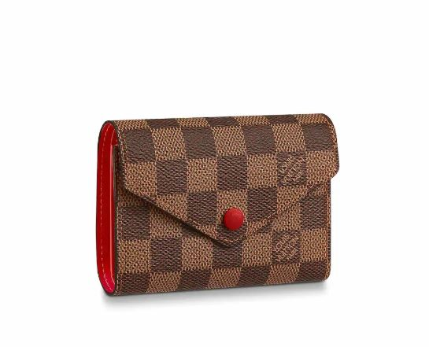LOUIS VUITTON - VICTORINE WALLET

##### **Detail**

The Victorine wallet in Damier Ebene canvas is a compact, envelope-style design which opens out to reveal a range of practical features, including space for bills and cards, and a zipped coin pocket on the side. Its colorful press-stud and grained-leather lining add a touch of femininity.

12.0 x 9.5 x 2.5 cm  
(Length x Height x Width)

* L 4.7 x H 3.7 x W 1 inches
* Cerise Red
* Damier Ebene coated canvas
* Grained cowhide-leather trim
* Grained cowhide-leather lining
* Gold-color hardware
* Press-stud closure
* Zipped coin pocket
* Bill pocket
* 2 flat pockets
* 6 card slots

##### **CARE & COMPOSITION**

* leather
* imported